Project - High Level Design
On
Chat With Retail Document (RAG)

  - GEN AI

Institution Name: Medicaps University – Datagami Skill Based Course

BY
Sr no | Student Name | Enrolment Number
1 | Shivani Vishwakarma | EN22CS301913
2 | Shivanshu Verma | EN22CS301917
3 | Shobha Goswami | EN22CS301922
4 | Shubh Kapadia | EN22CS301942
5 | Shubham Kumawat | EN22CS301943

Group Name: Group 06D8
Project Number: GAI-41
Industry Mentor Name:
University Mentor Name: Prof. Divya Kumawat
Academic Year:2026

Table of Contents
- Introduction.
  - Scope of the document.
  - Intended Audience
  - System overview.
- System Design.
  - Application Design
  - Process Flow.
  - Information Flow.
  - Components Design
  - Key Design Considerations
  - API Catalogue.
- Data Design.
  - Data Model
  - Data Access Mechanism
  - Data Retention Policies
  - Data Migration
- Interfaces
- State and Session Management
- Caching
- Non-Functional Requirements
  - Security Aspects
  - Performance Aspects
- References

1. Introduction
1.1 Scope of the Document
This document presents the high-level design of the Retail Document Intelligence System, an AI-powered application designed to enhance document understanding and retrieval in the retail domain. The system leverages Retrieval-Augmented Generation (RAG) to enable users to extract meaningful insights from unstructured documents such as reports, manuals, and policy documents.
The scope of this document includes:
- Overall architecture of the system
- Major system components and their responsibilities
- Data flow across different modules
- API structure and interaction patterns
- High-level data handling mechanisms
- Key design decisions and trade-offs
This document does not cover low-level implementation details such as specific code logic or algorithms, but instead focuses on how different parts of the system interact at a conceptual level.

1.2 Intended Audience
This document is intended for:
- Software developers and engineers involved in the system
- Academic evaluators and project reviewers
- Technical stakeholders interested in system architecture

1.3 System Overview
The Retail Document Intelligence System is designed to provide an intelligent interface for interacting with document-based knowledge.
The system allows users to:
- Upload retail-related PDF documents
- Automatically process and index the content

- Perform semantic search through natural language queries
- Receive context-aware answers generated by an AI model
The system is based on a RAG architecture, which combines:
- A retrieval mechanism (vector database) to fetch relevant document content
- A generation mechanism (LLM) to produce human-readable answers
This approach ensures that responses are grounded in the uploaded documents rather than relying solely on pre-trained knowledge.

2. System Design
2.1 Application Design
The application follows a layered client-server architecture with clear separation of concerns.
Frontend Layer
The frontend is built using React with TypeScript and serves as the user interaction layer. It provides:
- File upload interface
- Document management panel
- Chat interface for querying
- Real-time response display
Backend Layer
The backend is implemented using FastAPI and acts as the core processing unit. It handles:
- API request handling
- Document ingestion and processing
- Embedding generation
- Query execution and response generation
AI Processing Layer
This layer includes:
- Embedding model for semantic vector creation
- Vector database (FAISS) for similarity search

- LLM (Gemini) for natural language generation

2.2 Process Flow
The system consists of two primary workflows:
A. Document Upload and Indexing Flow
When a user uploads a document:
- The frontend sends a POST request to the backend
- The backend stores the file temporarily
- The document is loaded and text is extracted
- The text is divided into smaller chunks
- Each chunk is converted into embeddings
- The embeddings are stored in the vector database
This process converts unstructured text into a searchable format.
B. Query Processing Flow
When a user submits a query:
- The query is sent to the backend
- The query is converted into an embedding
- The vector database retrieves the most relevant chunks
- Retrieved chunks are combined into context
- Context and query are passed to the LLM
- LLM generates a response
- Response is returned to frontend

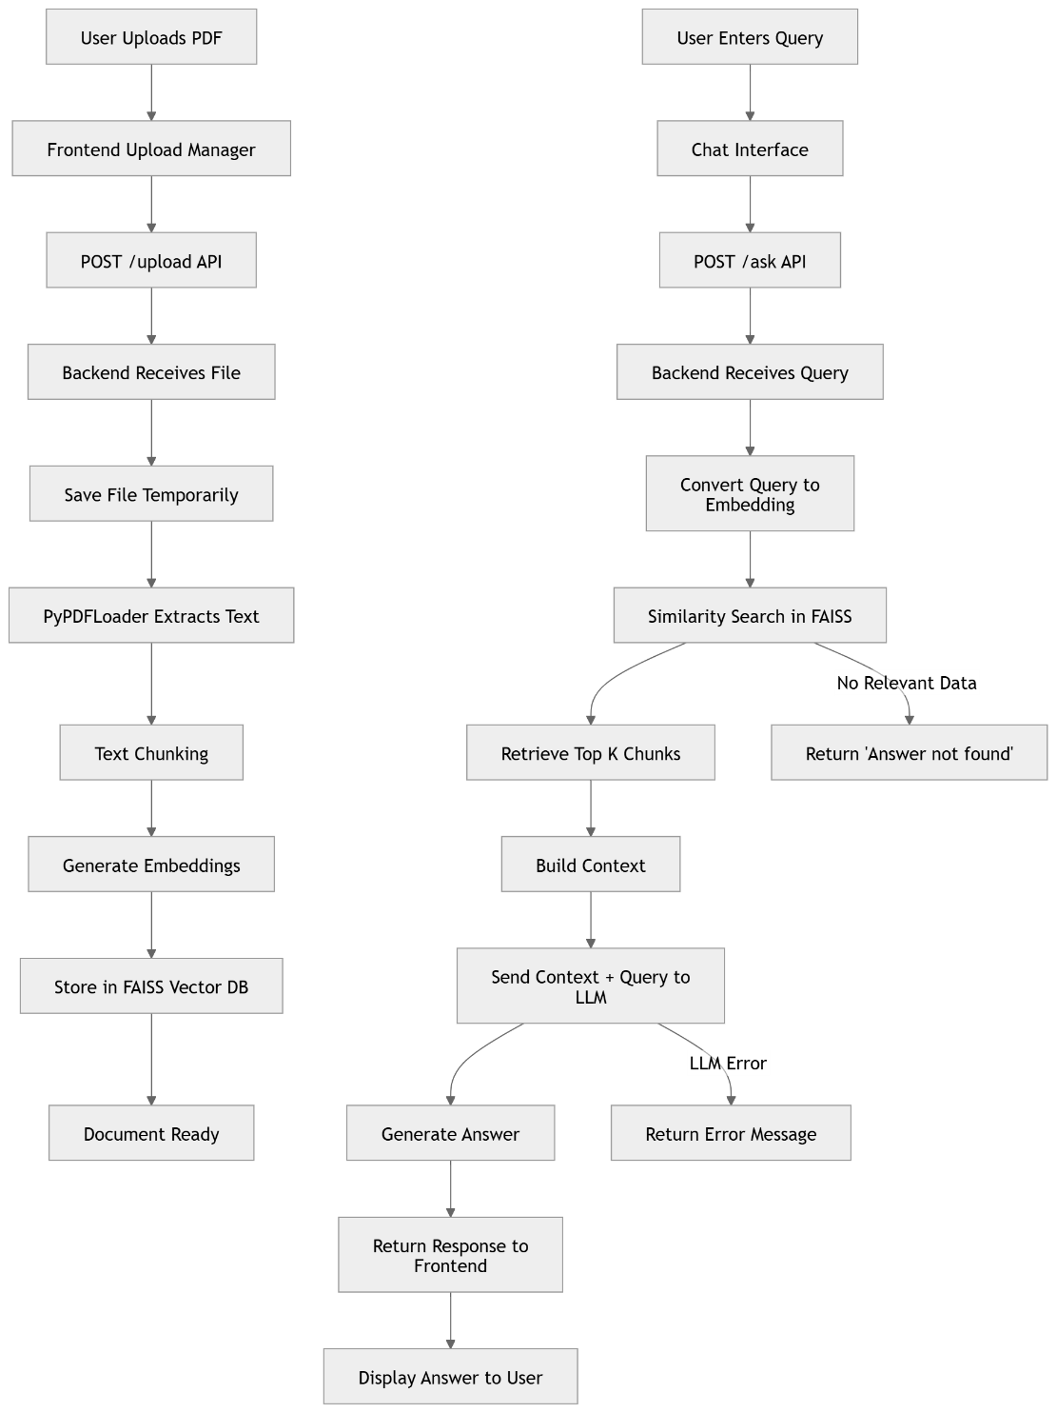
Process Flow Diagram
2.3 Information Flow
The system supports two major data flows:
Upload Flow
User → Frontend → Backend → Processing Module → Vector Database
Query Flow
User → Frontend → Backend → Vector Database → LLM → Response

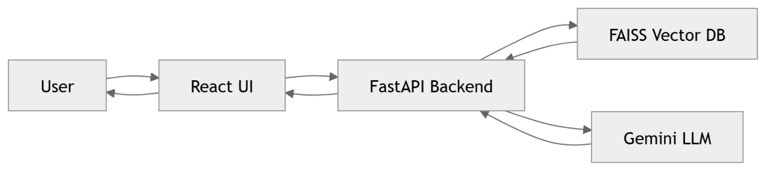
Information flow diagram

Internal Transformations
- Raw PDF → Extracted text
- Text → Chunks
- Chunks → Embeddings
- Query → Embedding
- Embedding → Similar chunks
- Context → Answer

2.4 Components Design
Frontend Components
The frontend layer acts as the user interaction interface, enabling users to interact with the system in an intuitive and efficient manner. It is designed to provide a seamless experience for document management and querying.
• Upload Manager
The Upload Manager is responsible for handling document uploads from the user. It allows users to select and submit PDF files to the backend for processing.
- Supports file selection and upload
- Sends files to backend via API
- Displays upload progress/status

Sidebar for Document Listing
The Sidebar provides a structured view of all uploaded documents. It helps users manage and navigate through available files.
- Displays list of uploaded documents
- Shows document status (processed/processing)
- Allows deletion of documents
- Enables quick selection and management

• Chat Interface
The Chat Interface is the core interaction module where users can ask questions related to uploaded documents.
- Accepts natural language queries
- Displays AI-generated responses
- Provides a conversational experience
- Shows loading/processing indicators

Backend Components
The backend layer is responsible for processing requests, managing data, and integrating AI functionalities. It serves as the central logic controller of the system.
• API Controller
The API Controller acts as the entry point for all client requests. It handles routing and directs requests to appropriate services.
- Manages endpoints such as /upload, /ask, /documents
- Validates incoming requests
- Coordinates between different backend modules
• Document Processor
The Document Processor handles the extraction and preparation of text from uploaded PDF files. It ensures that raw document data is converted into a usable format.

- Extracts text from PDF documents
- Cleans and preprocesses text
- Splits text into smaller chunks for processing
• Embedding Generator
This component converts textual data into numerical vector representations using an embedding model.
- Transforms text chunks into embeddings
- Captures semantic meaning of content
- Prepares data for similarity-based retrieval
• Vector Store Manager
The Vector Store Manager is responsible for storing and managing embeddings efficiently.
- Stores embeddings in vector database (FAISS)
- Performs similarity search operations
- Retrieves relevant data based on query vectors
• Query Engine
The Query Engine processes user queries and coordinates retrieval operations.
- Converts query into embedding
- Fetches relevant document chunks
- Prepares contextual data for response generation
• LLM Handler
The LLM Handler interacts with the external language model to generate final responses.
- Sends query and context to LLM
- Generates human-readable answers
- Ensures responses are coherent and context-aware

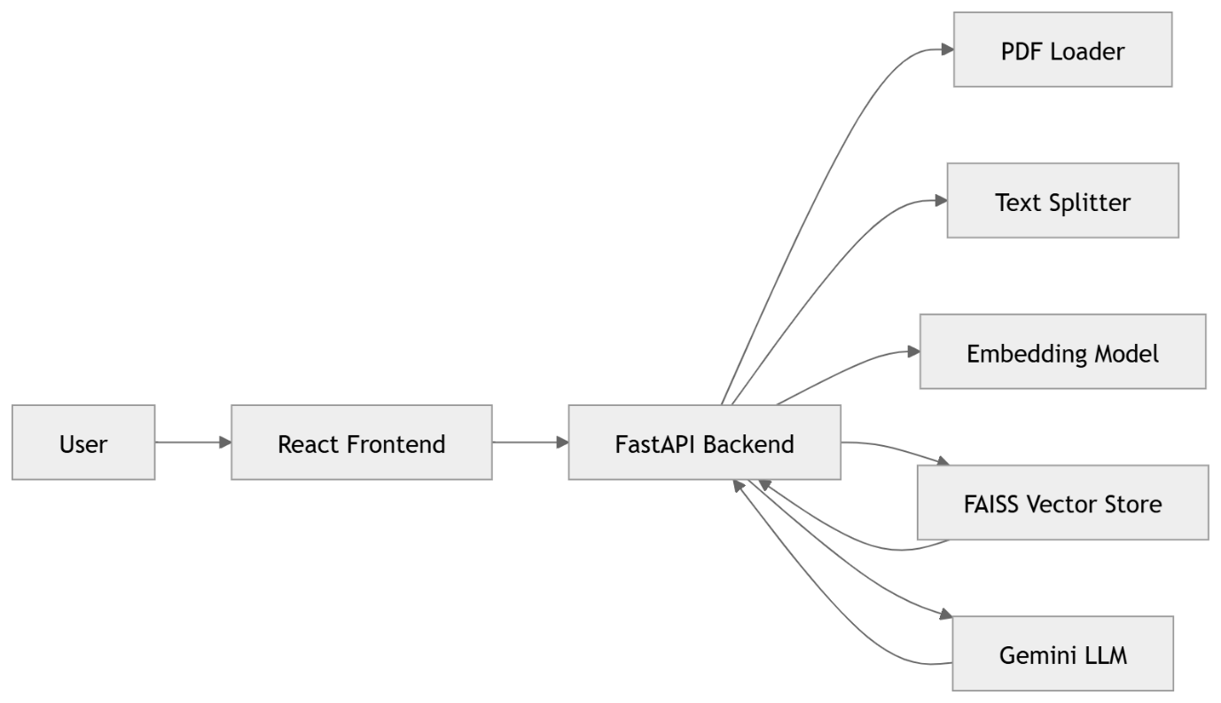
Architecture diagram

2.5 Key Design Considerations
Scalability
Current system uses in-memory storage, limiting scalability. Future enhancements may include persistent vector databases.

Performance
- Chunking improves processing efficiency
- FAISS enables fast retrieval
- Lightweight models reduce latency
Accuracy
- RAG ensures responses are grounded in document content
- Context-based answering reduces hallucination
Usability
- Chat-based interface improves user interaction

- Simple workflow enhances usability
Maintainability
- Modular architecture
- Clear separation of concerns

2.6 API Catalogue
Endpoint | Method | Description
/upload | POST | Upload and process documents
/documents | GET | Retrieve document list
/ask | POST | Process user queries
/documents/{id} | DELETE | Delete document

3. Data Design
3.1 Data Model
Document Metadata:
- Unique ID
- File name
- Upload timestamp
- Processing status
Vector Data:
- Text chunks
- Embedding vectors

3.2 Data Access Mechanism
- Metadata accessed via API
- Embeddings accessed via FAISS similarity search

- Retrieval based on semantic similarity

3.3 Data Retention Policies
- Files stored temporarily
- Embeddings stored in memory
- Data not persisted across sessions

3.4 Data Migration
- No migration strategy implemented
- Future enhancements may include database integration

4. Interfaces
The system provides:
User Interface
- Web-based interface for interaction
API Interface
- REST APIs using HTTP protocol

5. State and Session Management
The system is stateless:
- No session tracking
- Each request is independent
- No user authentication implemented

6. Caching
Currently, caching is not implemented.
However:

- FAISS acts as a fast retrieval layer
- Future improvements may include query caching

7. Non-Functional Requirements
7.1 Security Aspects
- CORS enabled for frontend-backend communication
- API key used for LLM authentication
- No user authentication (development scope)
7.2 Performance Aspects
- FastAPI ensures high throughput
- FAISS enables efficient similarity search
- Lightweight embedding model reduces latency
- System supports near real-time responses

8. References
- FastAPI Documentation
- FAISS Documentation
- Sentence Transformers
- Google Gemini API

